BUPI CLEANER® Cleaning Systems with New Software for the Internet of Things:
Ready for Industry 4.0

BUPI CLEANER® cleaning systems are now supplied with brand-new software that puts them on an entirely new technological foundation. With a functionality-oriented, modular and unified design, the platform architecture facilitates fast and easy configuration without programming. This further improves the efficiency and ergonomics of the cleaning equipment made in Salzburg and significantly reduces maintenance work, not least due to direct remote maintenance support from the manufacturer.

In the wake of the fourth industrial revolution, BUPI Golser decided in mid-2016 to develop an entirely new software platform for BUPI CLEANER® systems to be at the leading edge of the ongoing digitalisation process. Using the Siemens TIA-Portal development environment, they used object-oriented programming methods to design a functionality-oriented, modular and unified platform architecture. It creates a unified software foundation for the entire BUPI CLEANER® POWERTEC series as well as inline and custom cleaning systems made in Hallein near Salzburg by that long-established manufacturer.

Configuring not Programming
Equipment functionality can be combined in the fashion of building blocks to form complete systems. As selecting or deselecting functionalities does not require modifying the entire software, configuring a cleaning system including auxiliary equipment is a task performed by parameter setting only so it does not require programming skills. This greatly eases and accelerates the commissioning of cleaning systems and helps avoid errors.
Siemens colour touch panels with four, seven or twelve inch displays offer considerable benefits for configuration, operation and maintenance of the equipment. In case of infrequently performed actions such as emptying or cascade-filling the tanks, interactive illustrations provide guidance. All messages, warnings and errors are logged. Help text and the capability to display operating or maintenance manuals or circuit diagrams directly on the operator panels ease maintenance and accelerate trouble-shooting.

A direct Link to the Manufacturer

The current BUPI CLEANER® software has far-reaching capabilities for communicating with the outside world, for instance to cyclically pass on operating data acquired within the system. As a significant innovation, all BUPI CLEANER POWERTEC® systems running the current software are ready for remote maintenance. Via integrated routers, a secure connection to the BUPI Golser remote maintenance server can be established. Direct support from the system manufacturer is a valuable contribution to the high equipment availability that ultimately created the excellent reputation of BUPI CLEANER® systems.

“With the newly designed system software, we put the well-known virtues of our equipment on a technological foundation that is in line with the ongoing digital transformation”, BUPI Golser owner & Managing Director Markus Golser is convinced.
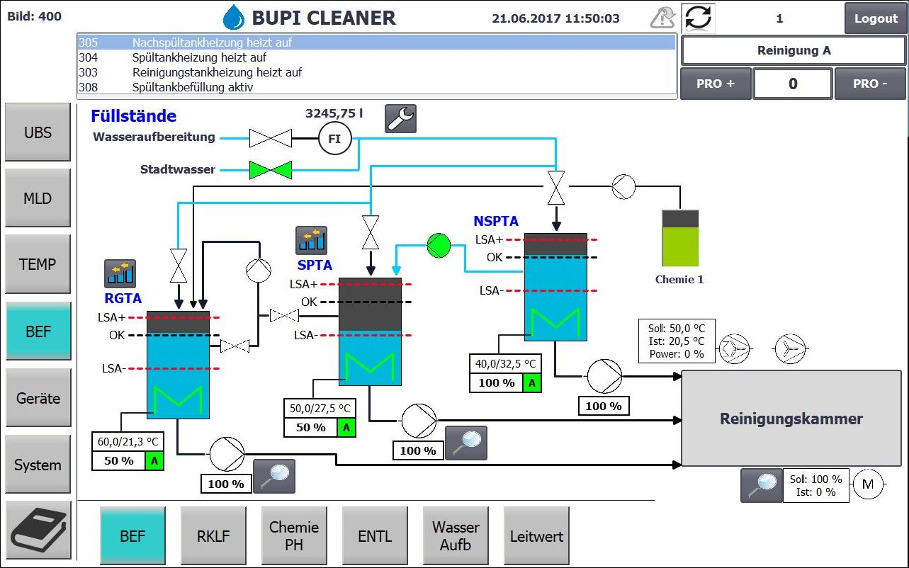

All BUPI CLEANER® POWERTEC systems are equipped with Siemens colour touch panels with four, seven or twelve inch displays depending on their complexity. These allow users to quickly and safely configure individual systems without requiring programming skills. The overview shows fluid levels and status information on all pumps and valves. Coloured lines illustrate the media flow.
Image: BUPI Golser

About BUPI Golser

BUPI Golser Maschinenbau GmbH, headquartered in Hallein near Salzburg, Austria, is a manufacturer and global supplier of part and container cleaning systems for industrial applications. The BUPI CLEANER® systems help customers to improve the overall efficiency of their production processes as well as their product and workplace quality and to reduce their water and energy consumption. This makes these systems indispensable components of many modern production facilities around the globe and BUPI Golser a market leader in the field of industrial cleanness.

For more information, please visit www.bupicleaner.com.

